**Transferring Data to and from the Robot**

Transferring data to and from the robot is fairly simple using three scripts included in the root directory:

**makeBag.py:**

This script records a bag file to the robot under a specific name and for specific topics. The script can be executed on the robot through a shell by inputting the command python makeBag.py The contents of this script is a single line that automatically inputs the ROS command into the terminal and ensures that it is consistent for each execution. This reduces the chance of a typo from the end user or having to scroll through a command list, simplifying its use.

The anatomy of the command is:

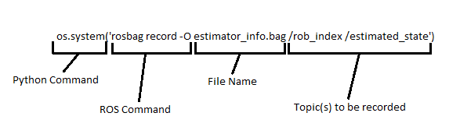

This command can be edited using any text editor. Stop execution of this script when desired data collection is completed.

**convertBag.py:**

After data collection, this script will extract the information from the bag file and place it into a CSV file that can be used for data processing and visualization using your favorite software (I recommend Python with pandas, but you could also use MATLAB, R, or even Java fairly easily). Simply run the script like makeBag on the robot using the command python convertBag.py This script is hard-coded to work with the file name output by makeBag.py. If the file name is changed, the file name in the script will need to be changed on line 16. The hard-coding is due to the fact that this script may be run dozens of times throughout a testing period, and prompting for input slows the workflow and can make the process prone to errors (typos).

**getBag.bat:**

This is the client script for transferring the completed CSV to a separate windows machine for processing. It is a simple script the opens an SSH connection to the robot and copies the file. Ensure that you have reviewed the document pertaining to remote connection of the robot. This script is also hard-coded to connect to a specific robot and extract a specific file. Any changes to the robot being used or changes to the file name will require that these parameters be adjusted in the script. This is also a batch script, and is written to be executed on a Windows machine. Similar commands can be used for a Linux or Mac machine, but will require that the script be changed to a bash script, the putty commands (pscp) be changed to bash commands (scp), and windows specific syntax be altered or removed.